Practical Info
9th Steering Group Meeting of Priority Area 9 of the EU Strategy for the Danube Region "Investing in People and Skills"

- Location and Venue

The meeting will be held on:
28 May 2015, 10:00-17:00
29 May 2015, 10:00-13:00

in
Hotel Podgorica (see map)
Ulica Svetlane Kane Radevic 1
Podgorica, Montenegro
Cell: +382 (0)67 231 339
Tel/fax: +382 20 402 500
Tel/fax: +382 20 402 501
recepcija@hotelpodgorica.co.m

- Travel and accommodation costs

Please note that for participants from Non-EU Member States in the Danube Region, international travel costs can be reimbursed up to € 500 (upon request). Accommodation costs will be reimbursed this time for all confirmed participants (except for members of the European Commission and/or International Organisations).

Please send your bills and tickets to the following addresses via postal service:

Participants from education ministries:  KulturKontakt Austria  Bildungskooperation  Jörg Musterle  Universitätsstraße 5  A-1010 Vienna  Austria | Participants from labour ministries:  L&R Sozialforschung  Katrin Leodolter  Liniengasse 2A/1  A-1060 Vienna  Austria

- Meals

The Federal Ministry of Education and Women’s Affairs, Austria, as well as the Federal Ministry of Labour, Social Affairs and Consumer Protection, Austria, are pleased to invite you for dinner on, Thursday, 28th of May. The venue is as follows:

Dinner at Restoran Pizzeria Lazaro, Thursday 28th May 2015, 19.30 – 21.30
Address: 13. Jula 23, Podgorica, Montenegro
Phone Number: 00382 69 060 502

- Hotel
Hotel Podgorica (Link)
Ulica Svetlane Kane Radevic 1
Podgorica, Montenegro

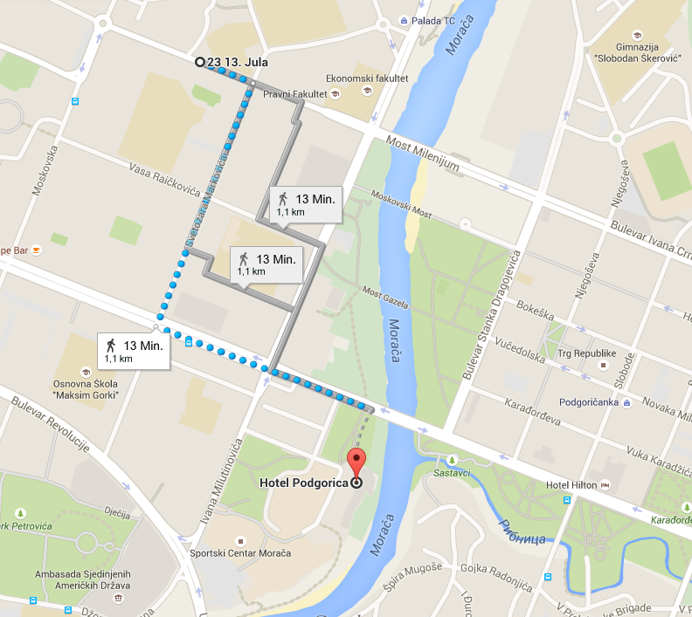
Restoran Pizzeria Lazaro

