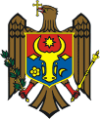  Ministry of Regional Development and Constructions of the Republic of Moldova | 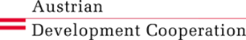 | State Chancellery  of the Republic of Moldova

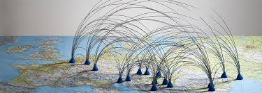
Project title: Danube connects
Project duration: February 2015 –January 2018
Budget: 479 930 EUR
Project Beneficiary: Ministry of Regional Development and Constructions
Project Partner: State Chancellery
Overall objective: to strengthen the capacities of Moldovan institutions at central, regional and local levels to participate in European development projects by creating an efficient coordination system at national level of the initiatives/programmes/instruments addressing regional development and cross border cooperation issues.
Project purpose: to create the institutional and legal framework for coordination and implementation of the EUSDR, Cross Border Cooperation and Transnational Cooperation Programmes in the Republic of Moldova with the purpose of ensuring coherence, efficiency and the best possible impact in the region
Target groups:
- Central public authorities coordinating the EUSDR and the CBC & TNC Programmes
- CBC & TNC Programmes 2007-2013 grant beneficiaries and partners
- Potential applicants for CBC & TNC Programmes 2014-2020

Final beneficiaries: citizens of Moldovan regions that will directly benefit from present and future CBC/TNC projects’ outputs.
Expected Results
Expected Result 1: National structures for coordination and implementation of the EUSDR created and capacities of staff developed
Expected Result 2: EUSDR promoted on international, national, regional and local level
Expected Result 3: National system for management and control of regional and cross border cooperation programmes for the period 2014-2020 created and capacities for its implementation developed
Expected Result 4: Programming process for the CBC & TNC programmes 2014-2020 successfully accomplished in the Republic of Moldova by the end of the project
Expected Result 5: The capacities of the potential applicants for the future ENI CBC and TC Programmes for 2014-2020 are enhanced and public awareness of the regional and CBC cooperation is increase
Project Title: “Danube connects“

Activities

